22.10: a) If 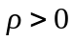 and uniform, then inside any closed surface is greater than zero. 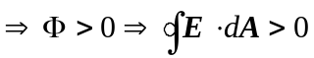 and so the electric field cannot be uniform, i.e., since an arbitrary surface of our choice encloses a non-zero amount of charge,  must depend on position.
b) However, inside a small bubble of zero density within the material with density , the field CAN be uniform. All that is important is that there be zero flux through the surface of the bubble (since it encloses no charge). (See Exercise 22.61.)

